Go to www.dcssga.org
Click Resources then Parents
Click Infinite Campus Parent Portal
Click ‘To obtain an activation key’
Enter the student’s information. If you did not provide the student’s SSN then you will need to get the activation key from the school.
Click Submit
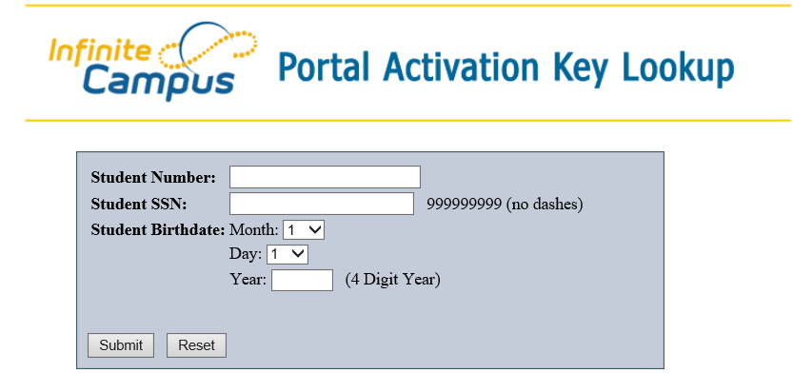
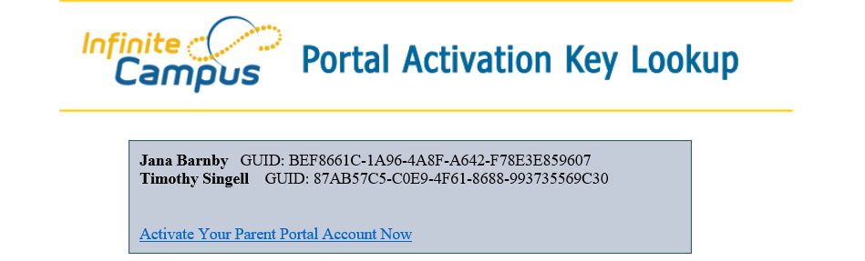
**Make sure you write down the GUID activation key.**
Click Activate Your Parent Portal Account Now
Enter the GUID Activation Key and click Submit
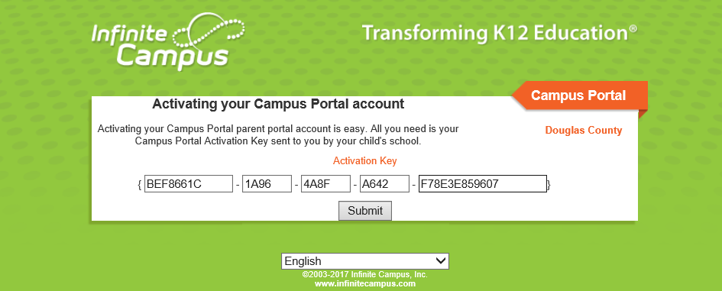
Create a username and password.
The status bar needs to be green and show 100% for the password to be useable.
Click Create Account
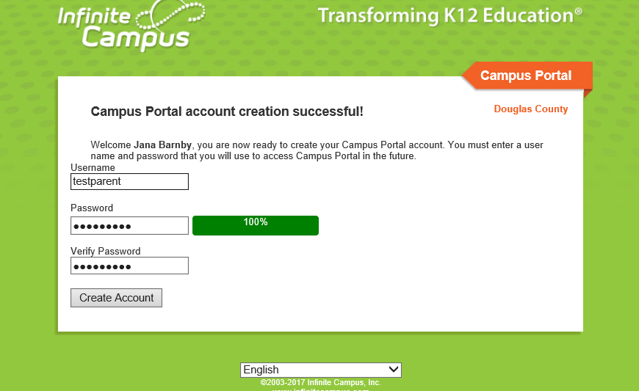

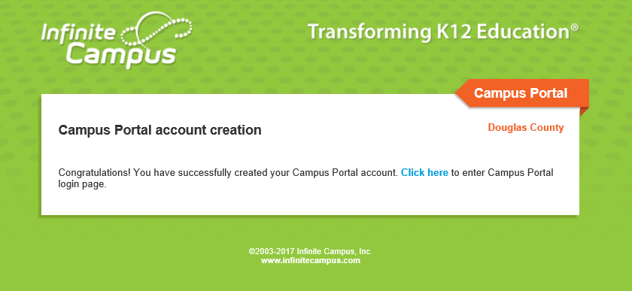
Click here to sign into your Parent Portal
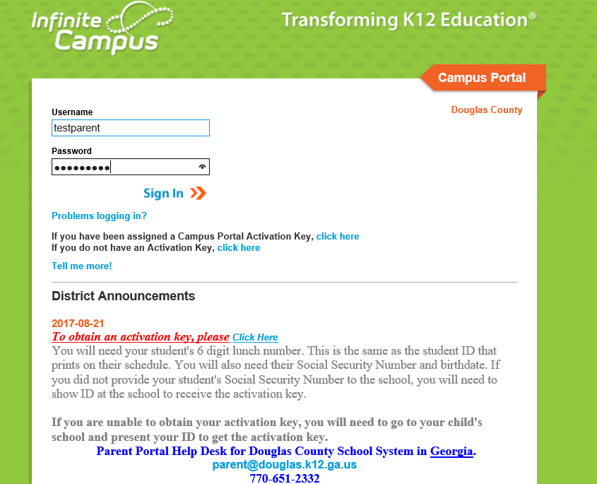
For additional assistance, contact the Parent Portal Help Desk.

